**Experiment-01**

**Aim:**

Define a class ‘product’ with data members pcode, pname and price. Create 3 objects of the class and find the product having the lowest price.

**CO1:**

Understand object-oriented concepts and design classes and objects to solve problems.

**Procedure:**

import java.util.*;

class product{

int pcode;

String pname;

int price;

public void get() {

Scanner sc = new Scanner(System.in);

System.out.println("Enter the product code:");

pcode = sc.nextInt();

System.out.println("Enter the product name:");

pname = sc.next();

System.out.println("Enter the product price:");

price = sc.nextInt();

}

public void display(){

System.out.println("Product code is: "+pcode);

System.out.println("Product name is: "+pname);

System.out.println("Product price is: "+price);

}

public static void main(String[] args){

product ob1 = new product();

product ob2 = new product();

product ob3 = new product();

ob1.get();

ob1.display();

ob2.get();

ob2.display();

ob3.get();

ob3.display();

if(ob1.price<ob2.price && ob1.price<ob3.price)

{

System.out.println("first product has lowest price");

}

else if(ob2.price<ob1.price && ob2.price<ob3.price)

{

System.out.println("second product has lowest price");

}

else

{

System.out.println("Third product has lowest price");

}

}

}

**Output Screenshot:**

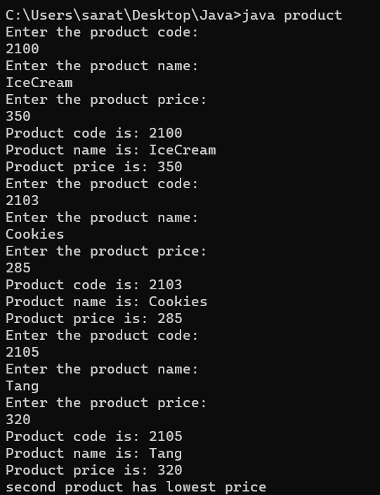

**Result:**

The output was successfully generated and the program was executed. Thus CO1 was attained.

**Experiment-02**

**Aim:**

Write a java program to perform matrix addition.

**CO1:**

Understand object-oriented concepts and design classes and objects to solve problems

**Procedure:**

import java.util.*;

public class Matrixadd{

public static void main(String[] args){

Scanner Snr = new Scanner(System.in);

System.out.println("Enter the dimensions of both matrix: ");

int rw = Snr.nextInt();

int cl = rw;

int Mtx1[][] = new int[rw][cl];

int Mtx2[][] = new int[rw][cl];

int Mtx3[][] = new int[rw][cl];

System.out.println("Enter the elements in first matrix: ");

for(int i=0;i<rw;i++){

for(int j=0;j<cl;j++){

Mtx1[i][j] = Snr.nextInt();

}

}

System.out.println("The First matrix: ");

for(int i=0;i<rw;i++){

for(int j=0;j<cl;j++){

System.out.print(Mtx1[i][j] + " ");

}

System.out.println(" ");

}

System.out.println("Enter the elements in second matrix: ");

for(int i=0;i<rw;i++){

for(int j=0;j<cl;j++){

Mtx2[i][j] = Snr.nextInt();

}

}

System.out.println("The Second matrix: ");

for(int i=0;i<rw;i++){

for(int j=0;j<cl;j++){

System.out.print(Mtx2[i][j] + " ");

}

System.out.println(" ");

}

System.out.println("The sum of the matrices: ");

for(int i=0;i<rw;i++){

for(int j=0;j<cl;j++){

Mtx3[i][j] = Mtx1[i][j] + Mtx2[i][j];

}

}

for(int i=0;i<rw;i++){

for(int j=0;j<cl;j++){

System.out.print(Mtx3[i][j] + " ");

}

System.out.println(" ");

}

}

}

**Output Screenshot:**

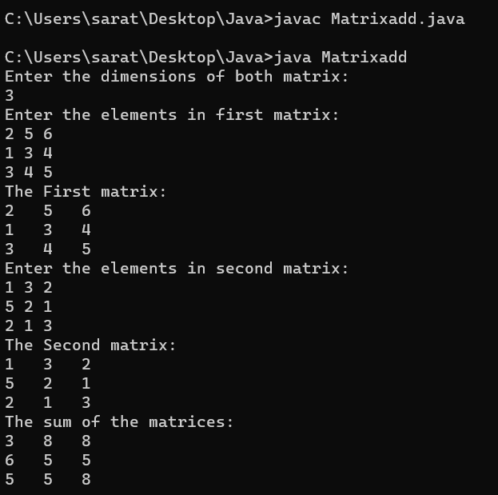

**Result:**

The output was successfully generated and the program was executed. Thus CO1 was attained.

**Experiment-03**

**Aim:**

Write a java program to add complex numbers.

**CO1:**

Understand object-oriented concepts and design classes and objects to solve problems

**Procedure:**

import java.util.*;

public class Complex{

public static void main(String[] args){

Scanner Snr = new Scanner(System.in);

System.out.println("Enter the real part of first imaginary number: ");

int r1 = Snr.nextInt();

System.out.println("Enter the coefficient of the first imaginary constant: ");

int i1 = Snr.nextInt();

System.out.println("Enter the real part of second imaginary number: ");

int r2 = Snr.nextInt();

System.out.println("Enter the coefficient of the second imaginary constant: ");

int i2 = Snr.nextInt();

System.out.println("The first imaginary number is "+r1+" + "+i1+"i");

System.out.println("The second imaginary number is "+r2+" + "+i2+"i");

int r3=r1+r2;

int i3=i1+i2;

System.out.println("The sum of the two imaginary number is "+ r3 +" + "+ i3 +"i");

}

}

**Output Screenshot:**

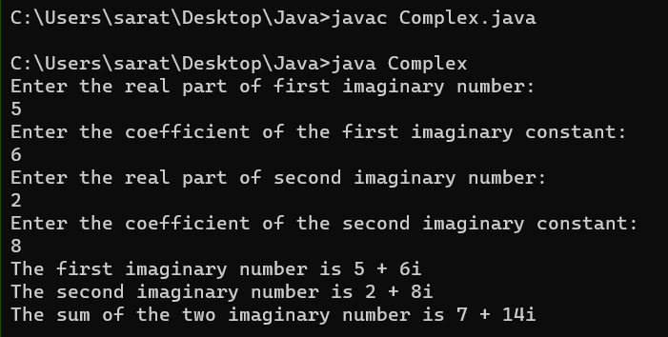

**Result:**

The output was successfully generated and the program was executed. Thus CO1 was attained.

**Experiment-04**

**Aim:**

Write a java Program to check whether a matrix is symmetric or not.

**CO1:**

Understand object-oriented concepts and design classes and objects to solve problems

**Procedure:**

import java.util.*;

public class SymmetricMatrix{

public static void main(String[] args){

Scanner Snr = new Scanner(System.in);

System.out.println("Enter the dimension of the matrix :");

int sz = Snr.nextInt();

int Arr[][] = new int[sz][sz];

int Arr1[][] = new int[sz][sz];

System.out.println("Enter the elements in matrix :");

for(int i=0;i<sz;i++){

for(int j=0;j<sz;j++){

Arr[i][j] = Snr.nextInt();

}

}

System.out.println("The matrix: ");

for(int i=0;i<sz;i++){

for(int j=0;j<sz;j++){

System.out.print(Arr[i][j] + " ");

}

System.out.println(" ");

}

System.out.println("The Transpose of the matrix: ");

for(int i=0;i<sz;i++){

for(int j=0;j<sz;j++){

Arr1[i][j]=Arr[j][i];

}

}

for(int i=0;i<sz;i++){

for(int j=0;j<sz;j++){

System.out.print(Arr1[i][j] + " ");

}

System.out.println(" ");

}

int flag=0;

for(int i=0;i<sz;i++){

for(int j=0;j<sz;j++){

if(Arr[i][j] != Arr1[i][j]){

flag=1;

break;

}

}

}

if(flag==1){

System.out.println("The matrix is not symmetric");

}

else{

System.out.println("The matrix is symmetric");

}

}

}

**Output Screenshot:**

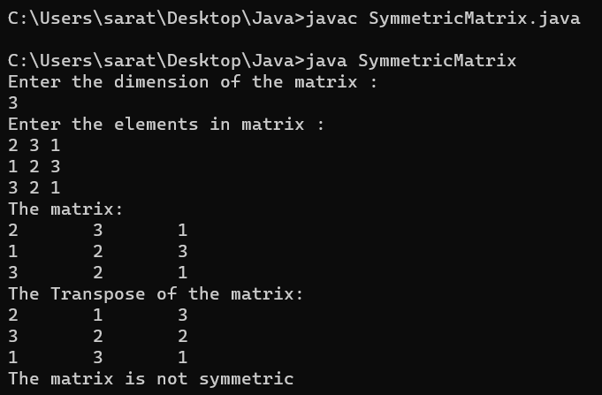

**Result:**

The output was successfully generated and the program was executed. Thus CO1 was attained.

**Experiment-05**

**Aim:**

**CO1:**

Understand object-oriented concepts and design classes and objects to solve problems

**Procedure:**

**Output Screenshot:**

**Result:**

The output was successfully generated and the program was executed. Thus CO1 was attained.

**Experiment-06**

**Aim:**

Write a java program to sort strings

**CO2:**

Implement arrays and strings.

**Procedure:**

import java.util.*;

public class stringSort{

public static void main(String[] args){

Scanner input= new Scanner(System.in);

System.out.println("Enter the string 1:");

String str1 = input.nextLine();

System.out.println("Enter the string 2:");

String str2 = input.nextLine();

System.out.println("Enter the string 3:");

String str3 = input.nextLine();

System.out.println("Enter the string 4:");

String str4 = input.nextLine();

System.out.println(str1.compareTo(str2));

System.out.println(str1.compareTo(str3));

System.out.println(str1.compareTo(str4));

}

}

**Output Screenshot:**

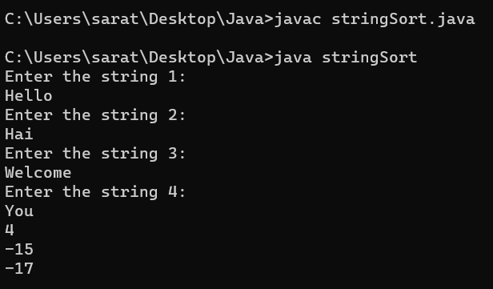

**Result:**

The output was successfully generated and the program was executed. Thus CO2 was attained.

**Experiment-07**

**Aim:**

Write a java program to search for an element in an array .

**CO2:**

Implement arrays and strings.

**Procedure:**

import java.util.Scanner;

public class linearSearch {

public static void main(String[] args) {

Scanner scanner = new Scanner(System.in);

System.out.print("Enter the size of the array: ");

int size = scanner.nextInt();

int[] arr = new int[size];

System.out.println("Enter the elements of the array:");

for (int i = 0; i < size; i++) {

arr[i] = scanner.nextInt();

}

System.out.print("Enter the element to search: ");

int elementToSearch = scanner.nextInt();

int position = -1;

for (int i = 0; i < size; i++) {

if (arr[i] == elementToSearch) {

position = i;

break;

}

}

if (position != -1) {

System.out.println("Element found at index " + position);

} else {

System.out.println("Element not found in the array");

}

}

}

**Output Screenshot:**

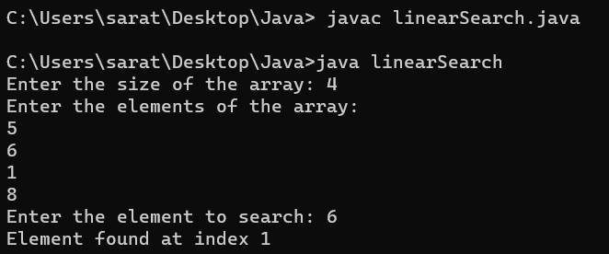

**Result:**

The output was successfully generated and the program was executed. Thus CO2 was attained.

**Experiment-08**

**Aim:**

Write a java program to perform String Manipulations.

**CO2:**

Implement arrays and strings.

**Procedure:**

import java.util.*;

public class stringMani{

public static void main(String[] args){

Scanner sc = new Scanner(System.in);

System.out.print("Enter the string 1: ");

String var1 = sc.nextLine();

System.out.print("Enter the string 2: ");

String var2 = sc.nextLine();

System.out.println("Concate :" + var1.concat(var2));

System.out.println("Equals :" + var1.equals(var2));

System.out.println("Length :" + var1.length());

System.out.println("To uppercase :" + var1.toUpperCase());

System.out.println("Substring :" + var1.substring(0,3));

System.out.println("CompareTo :" + var1.compareTo(var2));

}

}

**Output Screenshot:**

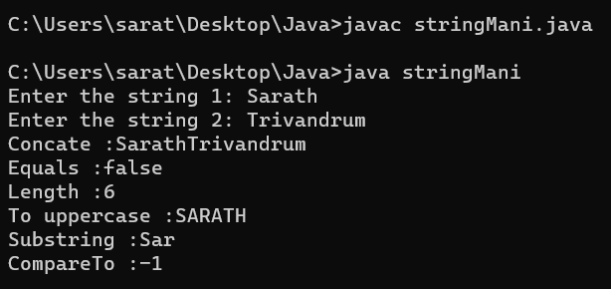

**Result:**

The output was successfully generated and the program was executed. Thus CO2 was attained.

**Experiment-09**

**Aim:**

Write a program to create a class for employee having attributes eno, ename, esalary. Read n employee information and search for an employee given eno using the concept of array of objects.

**CO1:**

Understand object-oriented concepts and design classes and objects to solve problems

**Procedure:**

import java.util.Scanner;

public class Emp{

int eno;

String ename;

int esalary;

public void get()

{

Scanner nw = new Scanner(System.in);

System.out.println("Enter employee number: ");

eno = nw.nextInt();

System.out.println("Enter employee name: ");

ename = nw.next();

System.out.println("Enter employee salary: ");

esalary = nw.nextInt();

}

public void display()

{

System.out.println("Employee number is "+eno);

System.out.println("Employee name is "+ename);

System.out.println("Employee salary is "+esalary);

}

public static void main(String[] args){

int i;

Scanner nw=new Scanner(System.in);

System.out.println("Enter the limit of array");

int n=nw.nextInt();

Emp e[]=new Emp[n];

for(i=0;i<n;i++)

{

e[i]=new Emp();

e[i].get();

}

for(i=0;i<n;i++)

{

e[i].display();

}

System.out.println("Enter the eno:");

int val=nw.nextInt();

int flag=0;

for(i=0;i<n;i++)

{

if(e[i].eno==val)

{

e[i].display();

flag=1;

}

}

if(flag==0)

{

System.out.println("Not Found");

}

}

}

**Output Screenshot:**

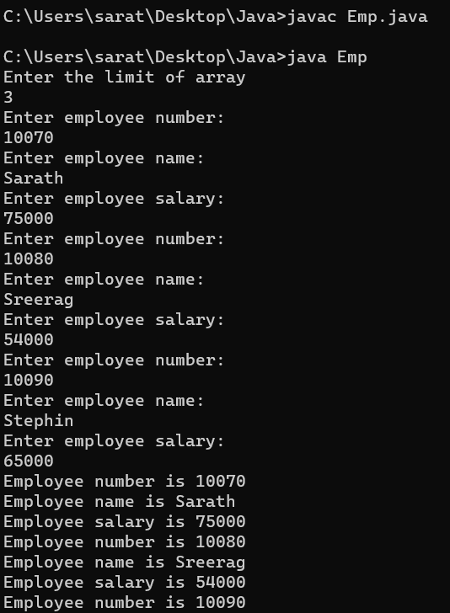 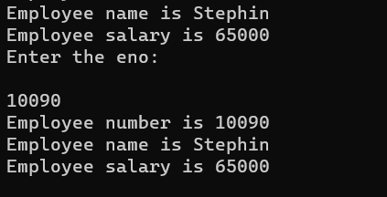

**Result:**

The output was successfully generated and the program was executed. Thus CO1 was attained.